成绩
批阅
日期

台州学院
电子与信息工程学院实验报告
Experimental Report of the School of Electronic and Information Engineering

班级(class) 24计算机（留）（英） 学号(code) 2462710034L
姓名(full name) JENIRA SEKAR AZ ZAHRA 仙女

实验课程： web前端开发 (web front-end development)
实验名称:实验一 HTML编程实践 (lab1 HTML Programming Practice)

实验日期(Date)： 2025 年(year) 9 月(month) 30 日(day)

一、实验目的和任务（Experimental requirements & tasks）
1. 了解HTML 文档结构，学习如何编写HTML文档；
（understand the structure of HTML documents and learn how to write HTML documents）
- 学习基本的 HTML 标签，理解各种标签的使用场景;
( Learn basic HTML tags and understand the usage scenarios of various tags)
- 能够运用常用的编辑器建立简单的HTML文档。
(eable to create simple HTML documents using common editors.)
- 实验环境(Experimental environments)
r Windows+Hbuilderx
r Windows+VSCode
r Mac+Hbuilderx
r Max+VSCode
r Others
- 实验内容与步骤(Experimental procedure)
- HTML structure:
<!DOCTYPE html>
<html lang="en">
<head>
<meta charset="UTF-8" />
<meta name="viewport" content="width=device-width, initial-scale=1.0" />
<title>Curriculum Vital</title>
<link rel="stylesheet" href="style.css" />
</head>
<body>
<div class="container">
<!-- header section -->
<header>
<div class="profile-section">
<div class="profile-photo">
<img src="img/pfp.jpg" alt="Profile Photo" />
</div>
<div class="personal-info">
<h1>Jenira Sekar</h1>
<p class="email">jenirasekar@gmail.com</p>
<p class="mobile-phone">(+86) 131 5769 3801</p>
<p class="address">No. 605, Dongfang Avenue, Linhai City, Taizhou City, Zhejiang Province, China</p>
</div>
</div>
</header>

<!-- education section -->
<section class="education-section">
<h2>Education</h2>
<div class="education-entry">
<h3>Master of Science in Computer Science</h3>
<p class="institution">University of California, Los Angeles (UCLA)</p>
<p class="duration">September 2021 - June 2023</p>
<ul>
<li>Specialization in Artificial Intelligence and Machine Learning</li>
<li>Relevant Coursework: Advanced Algorithms, Data Mining, Neural Networks</li>
<li>Thesis: "Optimizing Deep Learning Models for Image Recognition"</li>
</ul>
</div>
<div class="education-entry">
<h3>Bachelor of Technology in Information Technology</h3>
<p class="institution">Taizhou University, China</p>
<p class="duration">September 2017 - June 2021</p>
<ul>
<li>Graduated with First Class Honors</li>
<li>Relevant Coursework: Database Management, Web Development, Software Engineering</li>
<li>Final Year Project: "Development of a Web-Based Inventory Management System"</li>
</ul>
</div>
</section>

<!-- experience section -->
<section class="experience-section">
<h2>Experience</h2>
<div class="experience-entry">
<h3>Software Engineer Intern</h3>
<p class="company">Tech Solutions Inc., Los Angeles, CA</p>
<p class="duration">June 2022 - August 2022</p>
<ul>
<li>Developed and maintained web applications using React and Node.js</li>
<li>Collaborated with cross-functional teams to design and implement new features</li>
<li>Optimized application performance, resulting in a 20% reduction in load times</li>
</ul>
</div>
<div class="experience-entry">
<h3>Research Assistant</h3>
<p class="company">UCLA Department of Computer Science</p>
<p class="duration">September 2021 - May 2022</p>
<ul>
<li>Assisted in research on machine learning algorithms for natural language processing</li>
<li>Conducted experiments and analyzed data to evaluate model performance</li>
<li>Co-authored a paper published in the Journal of Artificial Intelligence Research</li>
</ul>
</div>
</section>

<section class="hobbies-section">
<h2>Hobbies</h2>
<ul>
<li>Traveling: Exploring new cultures and cuisines</li>
<li>Photography: Capturing moments through the lens</li>
<li>Reading: Enjoying fiction and non-fiction books</li>
<li>Fitness: Regularly practicing yoga and running</li>
</ul>
</section>
</div>
</body>
</html>

- CSS styling:
.container {
font-family: Arial, sans-serif;
margin: 0 auto;
padding: 0;
max-width: 1200px;
}

header {
background-color: #35424a;
color: #ffffff;
padding: 20px;
text-align: center;
}

header h1 {
margin: 0;
font-size: 2rem;
}

.profile-section {
display: flex;
justify-content: space-between;
align-items: center;
margin: 20px auto;
padding: 0 20px;
}

.profile-section .profile-photo img {
max-width: 120px;
border-radius: 50%;
object-fit: cover;
}

.profile-section .personal-info {
flex: 2;
text-align: right;
}

section {
background-color: #e2e2e2;
padding: 20px;
margin: 20px 0;
border-radius: 8px;
}

ul {
list-style: disc;
margin-left: 20px;
}

@media (max-width: 768px) {
.profile-section {
flex-direction: column;
text-align: center;
}

.profile-section .personal-info {
text-align: center;
margin-top: 10px;
}
}
- Result:
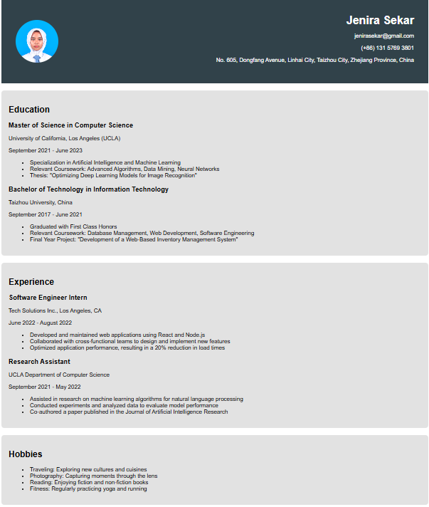

- Header section
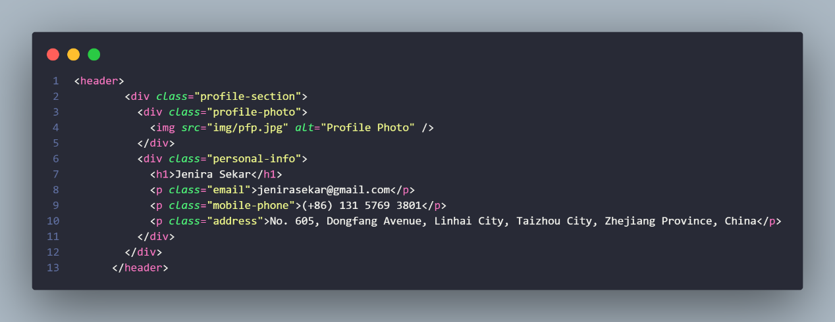
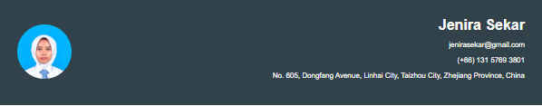
- Education section
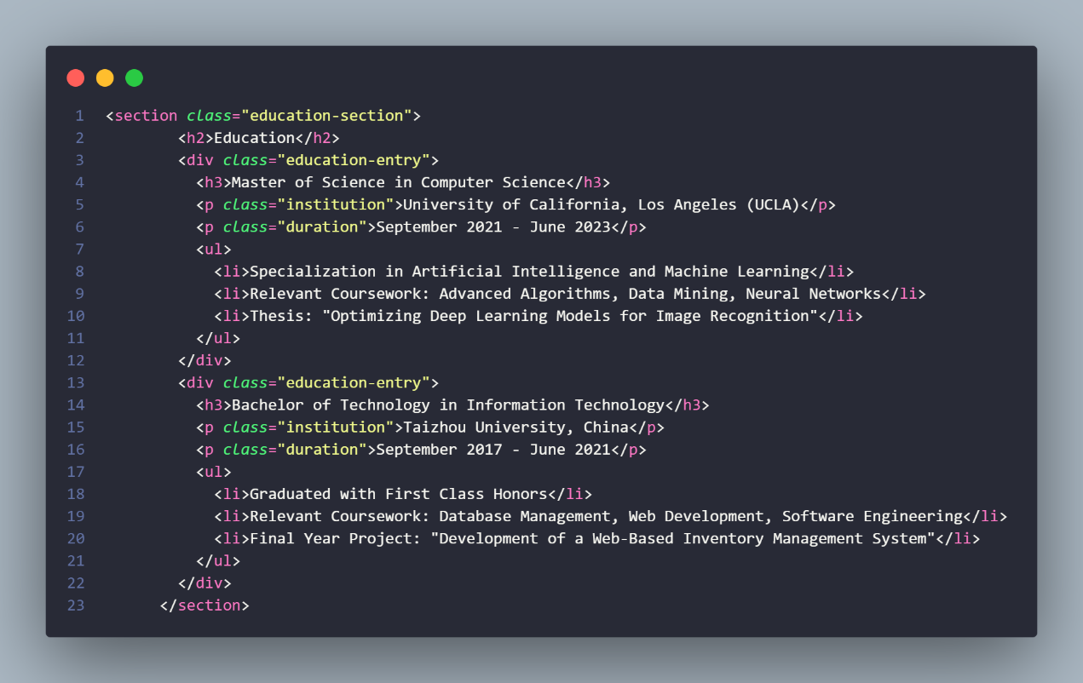

- Experience section
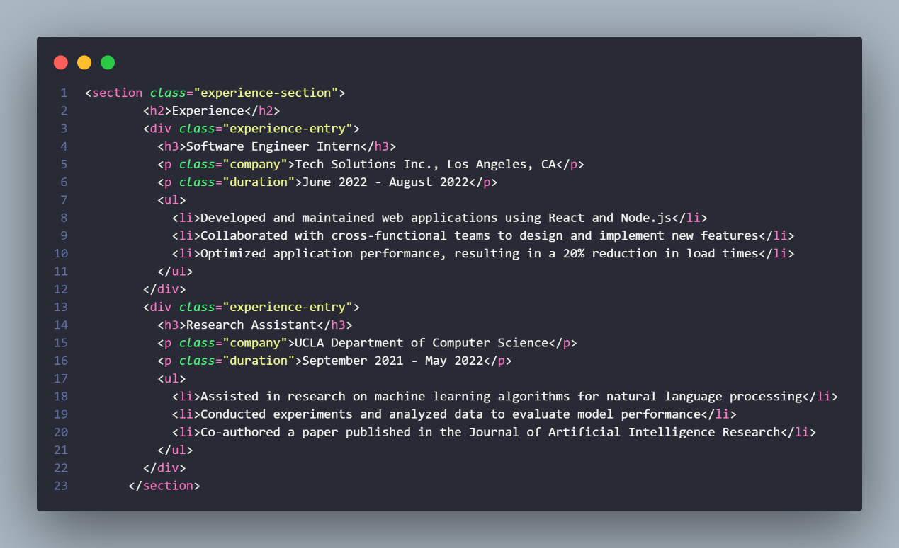
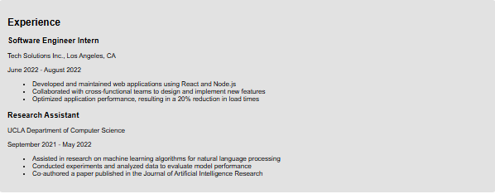
- Hobbies section
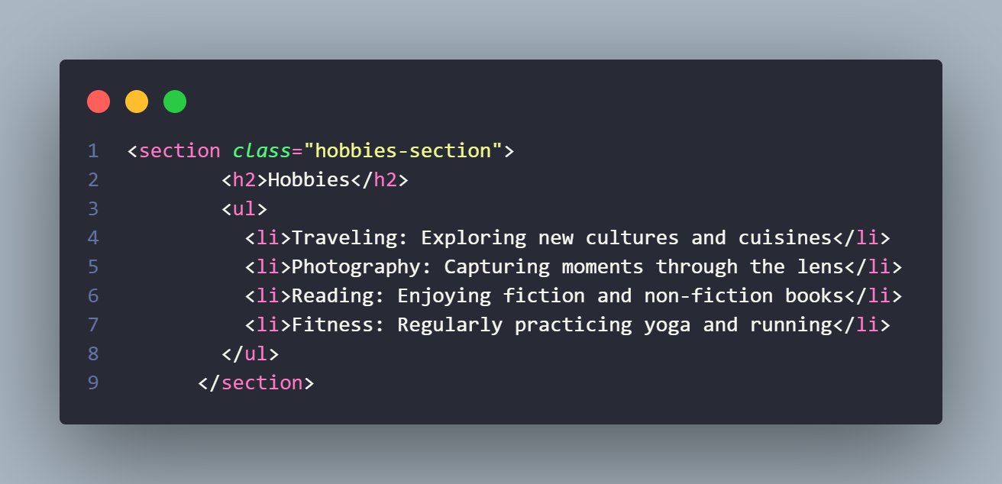
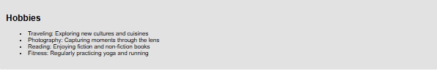
- 实验结果分析、思考、心得（Result reflection）

Through this experiment, I have deepened my understanding about HTML structure wholly with its tags and styling with CSS for more beautiful looking structure. It’s also seen in how to gain a better experience for a user using the website.

